Position Description

Position | Senior Policy Officer – Consumer Protection, Competition & Credit
Reports to | Director Policy and Campaigns
Direct reports | 1-2
Indirect reports | 0
Scope | Involvement in typically 2-6 campaigns per annum  Interaction with stakeholders at state and national level  Within Consumer Action, this position works closely with other team members, financial counsellors and solicitors. Externally, this position represents Consumer Action in collaboration with other consumer advocacy organizations, community legal centres and financial counselling services with an interest in consumer advocacy matters.

POSITION PURPOSE
The Senior Policy Officer, as a member of the Policy and Campaigns team, will identify, propose and provide policy analysis, research and strategic advice on consumer protection, competition and credit to further Consumer Action's mission of achieving more equitable outcomes for consumers.

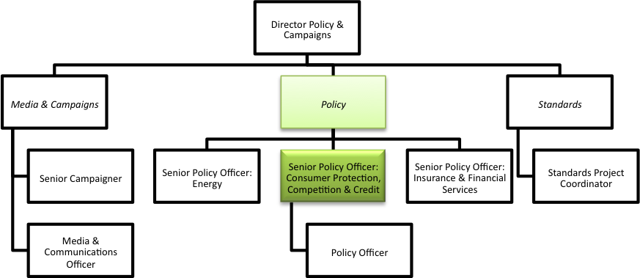

Key Responsibilities:
- Coordinate the development of policy positions relating to matters that advance the interest of low income and vulnerable consumers, with a particular focus on the policy and campaign priorities in the Annual Plan.
- Undertake policy research and prepare briefs, reports, articles, fact sheets and other materials in support of policy initiatives;
- Support the Director of Policy & Campaigns and the CEO in advocating to governments, regulators, businesses and others for the implementation of these policies
- Prepare submissions as part of relevant government and regulatory processes so that Consumer Action’s position is communicated and the Centre is recognized as a key stakeholder and credible expert in these processes;
- Establish and maintain relationships with experts, thought leaders policy makers and other influential stakeholders relevant to the position’s policy areas
- Represent Consumer Action at relevant consultative forums and work co-operatively with identified stakeholders so that Consumer Action contributes to policy development and is seen as a credible voice in public debate on issues of importance to low income and vulnerable consumers.
- Cooperate with and support the work of other advocacy organizations where this assists us to achieve good outcomes for consumers and builds capacity in the sector.
- Contribute to developing team and organizational goals as part of annual and project planning processes.
- Work with the legal practice and financial counselling service to identify and analyse issues arising from casework, and contribute to the development of strategy and projects to translate this analysis into advocacy action.
- Oversee and mentor the work of the Policy Officer(s) in order to support their learning and development in their role;
- Work collaboratively with the Media and Campaigns team to ensure effective coordination of Consumer Action’s public messages and positioning, and where appropriate act as a media spokesperson;
- Support the Director of Policy & Campaigns to identify funding opportunities in annual workplans and assist in the submission of funding applications to support core policy and project work

QUALIFICATIONS, EXPERIENCE AND RELEVANT SKILLS
- This position requires a tertiary degree in law or public policy, together with significant demonstrated experience, and a demonstrated commitment to advancing the public interest and social justice;
- Familiarity with theory and practice of policy making and research, particularly consumer policy, and regulatory issues, with specialist expertise in consumer protection, competition and credit;
- Significant experience in stakeholder management and advocacy and/or policy development at a national level

COMPETENCIES

- Curious to understand the multiple dimensions and uncertainties of the problems facing low income and vulnerable consumers, passionate about collaboratively developing and achieving innovative, practical policy solutions, and motivated to continually update knowledge and engage in critical reflection.

- Can synthesise information from diverse sources to produce high quality policy analysis and advice in a time-pressured environment.
- Ability to identify and analyse policy issues based on the Centre’s casework experience, and understanding of the relationship between client advocacy and systemic advocacy.
- Ability to design, develop, and implement complex projects; monitors and evaluates performance of projects against objectives and manages issues and roadblocks to ensure campaign objectives are met.

- Communicates in a clear and interesting way; understands the target audience and the objectives of the communication; uses feedback to refine communication; proven capacity to confidently undertake public speaking and represent the organisation through public consultation and media avenues, and effectively use online and other forms of public engagement.

- Cooperates and works well with others; shows consideration, concern and respect for others’ feelings and ideas; accommodates and works well with the different working styles of others, treating all people with dignity and respect.

- Works effectively with high degree of autonomy and accountability; self motivated and can demonstrate initiative, sound time management and ability to deal with competing priorities under pressure;
- Confident in mentoring, coaching and people management with a high level of awareness of personal impact;

