Position Description

Position | Director Policy and Campaigns
Reports to (position title) | Chief Executive Officer
Purpose: | The Director Policy and Campaigns leads the Policy and Campaigns team to strategise, plan and implement campaigns and policy activities which further Consumer Action's mission of achieving more equitable outcomes for consumers, particularly for those who are disadvantaged and vulnerable.
Direct reports: | 8
Indirect reports: | 0
Scope | Under the leadership of the Director, the team produces 50-60 submissions per year; gives 200-300 media comments, conducts 6-10 campaigns & policy projects, and involves membership of 5-8 national or state consultative bodies.

Organisation chart:

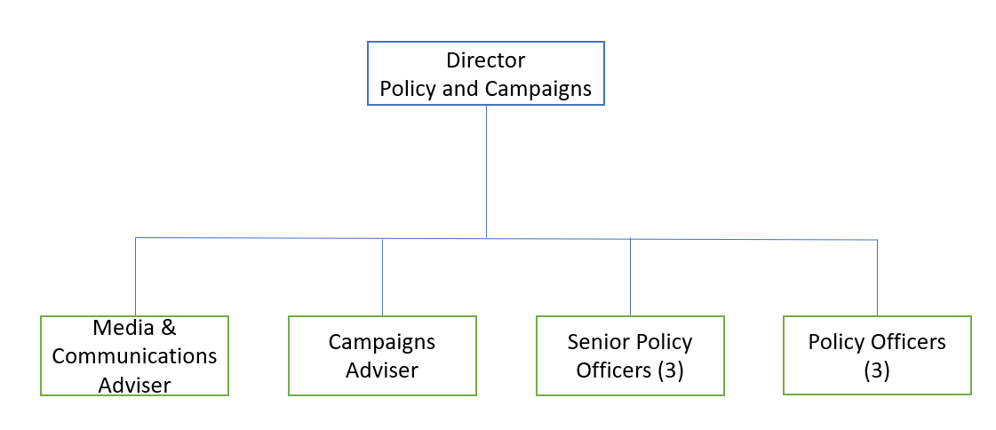

Key Accountabilities/Responsibilities:
- Act as a key source of Consumer Action’s expertise in shaping the legislative and policy agenda for consumer issues generally within Australia.
- Provide leadership and strategic direction for the Centre’s policy and campaigns work, including facilitating policy and campaign planning processes.
- Work with staff across the organisation to identify systemic issues and campaign opportunities arising from outreach, casework and advice services.
- Oversee media and communications activities and undertake media, events and presentation work.
- Undertake stakeholder liaison including participation in relevant consultative fora, and engagement at a decision-maker level with government departments, industry, parliamentarians and regulators.
- Author and/or oversee the production of policy and campaign material including media releases, reports, submissions, articles and fact sheets.
- As a member of the Consumer Action Law Centre Management team, contribute to the development of the Centre's strategic direction.
- Lead a team of 8 in the development and implementation of policies, campaign strategies and initiatives.
- Provide professional development support and mentoring opportunities for policy and campaign staff.
- Manage certain funding arrangements, including identifying and making funding applications to further the policy and campaign work of the Centre.
- Manage work systems, staffing procedures that support both team and individual performance.

Qualifications/Experience/Specialist skills:
- The Director Policy and Campaigns role requires a demonstrated commitment to advancing the public interest and social justice.
- An experienced and passionate people manager who can motivate staff and keep the team working to plan.
- Substantial experience in a policy and campaign development and influencing role.
- The role requires a tertiary qualification in a relevant discipline, or equivalent demonstrated experience and theoretical knowledge.
- Demonstrated specialist writing, editing and communication skills are also required.

Competencies

- Strong analytical and conceptual thinking skills with an ability to analyse the causes of consumer issues and to understand relevant legislation.
- Ability to think flexibly, innovatively and “outside the square”.
- High level of organisational awareness and understanding of political processes.
- Excellent time management and ability to deal with competing priorities under pressure.
- High level of self-awareness, ability to speak authoritatively and is comfortable appearing in the public eye.
- An assertive, patient, resilient, professional, organised, rational and creative leader who models high standards of performance.
- Highly developed sense of own impact; inspires and motivates a team; pro-actively models and promotes the maintenance of high ethical standards and organisational values.
- Expertise in complex stakeholder management and/or community engagement, including with Aboriginal & Torres Strait Islander organisations and communities.
- High level of cultural competency and values diversity and inclusion to support a culturally and psychologically safe workplace,

