Position Description

|  |  |
| --- | --- |
| Position | **Projects & Policy Officer (Aboriginal and/or Torres Strait Islander Identified)** |
| Reports to (position title) | *First Nations Projects & Policy Lead* |
| Purpose | *The Project & Policy Officer will support the effective delivery of projects, working as an integral part of a team to ensure timelines and deliverables are met and all project partners and stakeholders are effectively consulted and informed.*  *Bringing their honed organisational skills, willingness and excitement to learn and grow into the role, and a commitment to improving outcomes for First Nations consumers in Victoria, the Projects & Policy officer will form part of a small but highly effective team of First Nations professionals.*  *Also working alongside and with the support of the broader Policy & Campaigns team, the Projects and Policy Officer will collaborate and provide input into identifying, researching and developing reform solutions on issues that impact Victorian Aboriginal and Torres Strait Islander Communities.* |
| Direct reports: | *0* |
| Indirect reports: | *0* |
| Scope | *Supporting the Projects and Policy Lead to deliver the project, working with and for Victorian First Nations consumers to understand and fix the faulty used car sales practices in Victoria.*  *Also working closely and collaborating with other policy and campaigns team members, financial counsellors, solicitors and the First Nations Engagement Lead, as well as with a broad range of external sector stakeholders to contribute to policy outcomes impacting Victorian First Nations consumers.* |

**Organisational chart[1]:**

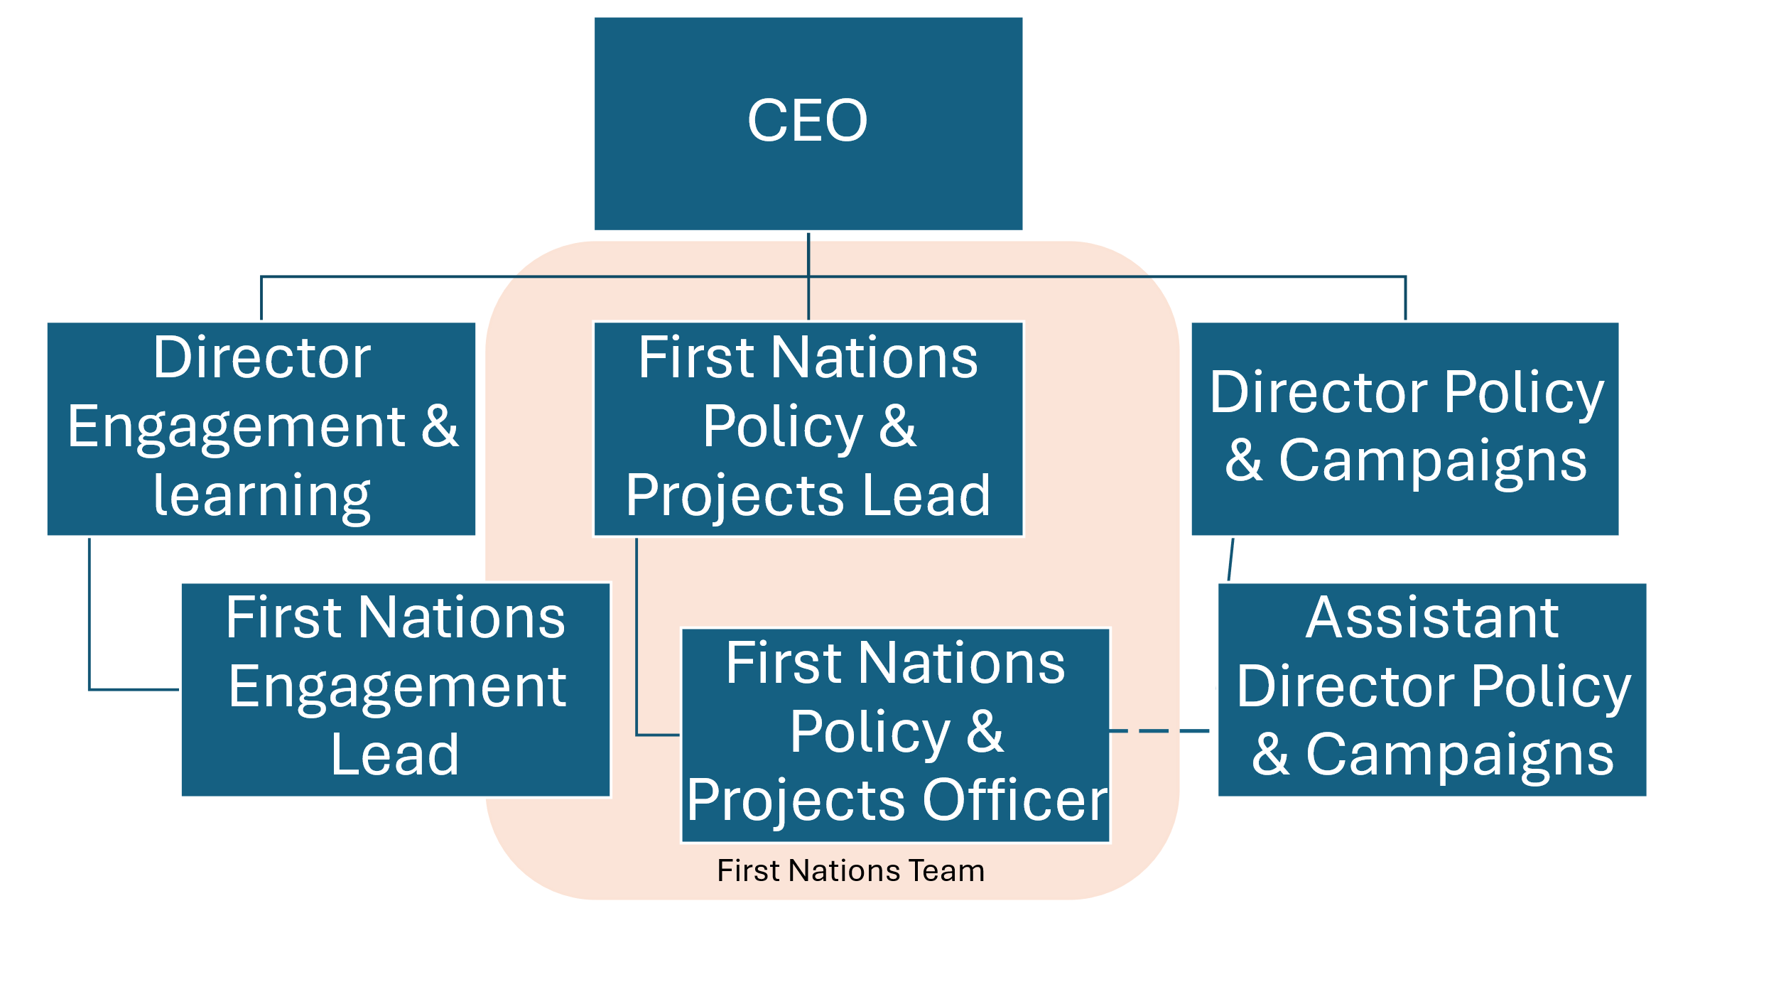

**Responsibilities:**

* Work collaboratively with and reporting to the First Nations Projects & Policy Lead in the maintenance of project plans, ensuring the timely delivery of project activities.
* Project administration and support, including timeline management and task creation, following up and supporting project stakeholders and partners in the delivery of their project commitments.
* Drafting project documentation and artefacts including partnership agreements, reports, marketing and communications material.
* Coordination and attendance of stakeholder engagement activities, in partnership with the First Nations Engagement Lead as required. Including travel and accommodation arrangements, room booking and coordination, catering etc.
* Liaising and relationship building with community and sector stakeholders including Aboriginal Community Controlled Organisations, relevant support services, regulators, and partner organisations including community service organisations and industry partners where appropriate.
* Working with and supporting project consultant(s) as required
* Meeting preparation and support as required, including development of agendas and meeting papers, taking and distributing minutes, creating and management of online meeting bookings etc.
* Working with the First Nations Projects & Policy Lead to contribute to the Policy & Campaign teams policy positions and statements.
* Undertake policy research and prepare briefs, reports and other materials in support of policy and advocacy activities as required.
* Contribute to and as directed, prepare submissions as part of relevant government and regulatory processes.
* Continue to foster relationships with external First Nations and broader consumer advocates, attending and engaging in stakeholder meetings as required and collaborating on work where possible.

**Qualifications and Experience**

* Tertiary qualification in a relevant discipline such as business, project management, law, economics or public policy will be **highly regarded**.
* Alternatively equivalent demonstrated experience in policy and/or projects or in a similar field is required, together with a commitment to advancing social justice outcomes.

**Key Selection Criteria**

* Community minded and confidently able to communicate with First Nations people and their representatives, as well as professionals from a range of stakeholder groups, and adept at tailoring communication styles to suit relevant audiences.
* Experience in and/or demonstrated understanding of project administration including effective planning, communication and timeline and priority management
* Excellent written and verbal communication and highly competent in utilising a broad suite of IT applications
* Can synthesise information from diverse sources to deliver research and policy analysis.
* Highly organised and self-motivated, can confidently work independently and with others and can ask for help and guidance when needed
* Ability to be part of team discussions as we work together to better understand the needs and experiences of community
* Understanding of the complexities of projects that are led by and for First Nations people and commitment to the principles of self-determination
* Shows consideration, concern and respect for others’ feelings and ideas; accommodates and works well with the different working styles of others
* A knowledge of the general business of Consumer Action and a commitment to our vision and values.

**About Consumer Action**

*Consumer Action Law Centre (Consumer Action) is an independent, not-for-profit consumer advocacy organisation, with the purpose to make life easier for people experiencing vulnerability and disadvantage. Consumer Action operates as a community legal centre, a financial counselling centre, and a nationally recognised and influential policy and research body. Our services include telephone and online-chat based financial counselling, legal advice (including a dedicated Koori Helpline), legal representation, and capacity building through sector training. We have a proud history of success because of the model for reform we follow – that is to identify problems through our casework and the data we get from our frontline advice services and advocating for fair business practices and law reform.*

*On the land of the Traditional Owners across Victoria, our dedicated staff work collaboratively and deliver integrated services and projects. We have just over 50 employees and promote a diverse and inclusive culture which upholds our values of respect, fairness, reflection and courage. We strive to be an employer of choice and provide employee benefits which supports work-life balance.*

*We are deeply committed to our journey towards cultural safety across the organisation, with the development and publication of a Cultural Safety Framework in 2023/2024 and commencement of Reconciliation Action Planning process, including mandatory cultural awareness training for all employees commencing in 2024/2025. We aim to increase our number of First Nations identified employees in 2025 and will be developing a connected and well-supported team under the advice of our First Nations Advisory Committee.*

*More about Consumer Action can be found on our* [*website*](https://consumeraction.org.au/about/)*, including our Strategic Plan and Impact Report.*

**About the role**

*This role supports the First Nations Projects and Policy Lead to deliver a First Nations-led project to reduce harm caused by licenced traders selling faulty vehicles and barriers to exercising legal protections. To do this, we will collaborate with First Nations partners across Victoria to:*

* *understand experiences of harmful industry practices and barriers to recourse*
* *develop culturally appropriate solutions, and*
* *support First Nations advocacy for change.*

*Learnings from this project will inform a model and guidance on co-design with First Nations communities, to fill a known practice gap in consumer advocacy, legal assistance and comparable settings.*

*The role will also work closely and collaborate with Consumer Action’s policy and campaigns team, financial counsellors, solicitors and the First Nations Engagement Lead, as well as with a broad range of external sector stakeholders, to contribute to policy outcomes impacting Victorian First Nations consumers.*

1. Structure due for review 30 June 2025